IYRC 2016 Game Categories – ver1.0

1. | Kinder Mission

Summary

Level | Kindergarten ( 5-7 years old)
Team | Individual
Robot | Educational Robot Kit
Mission | Simple Addition & subtraction questions
Robot Building | In advance
Game Method | Mission completion within fixed time frame

Rules and Regulation:

The goal of this competition is to provide an event that requires students to solve some simple mathematics calculation and move the correct answer cube to the answer area.
The students are not allowed to use any tools to do the calculation when pick a question from the box provided. After solving the math problem, the student must move the answer cube to the answer area before picking a new question. They must try as fast as possible to do the calculation and move the answer cube to the answer area in the time given. Points will be given only for the correct answer.

A. Picking up a math question(Card) from a box ONLY when the referee instruct to do so, PLACE the card on the left of the start point, solve the question and control the robot to move the correct answer to the answer area, only one answer(block stick with number) can allow to be move in the answer area. Quickly control the robot back to the start point and pick up another question when the referee approve. Solve as many questions as possible during 3 minutes.

B. Each correct answer will score 1 point and the student with the higher points will be the winner. Answer is accepted and checked only after cube moved inside answer area. Robot allowed to move any cubes outside answer area freely.

C. Prizes and trophies will be awarded to the Top 6 participants.

D. Time limit for each game is 3 minutes.

E. No Extra time shall be played in an event of a DRAW. The winner will be decided by their age. (example: a 6 and 7 year old participants scored the same points, the 6 year old participant will be the winner due to smaller in age.)

F. The robot must not have any foreign part(includes rubber band, black tapes and scotch tapes). If found guilty, the player would be IMMEDIATELY disqualified.

G. Maximum size of robots are limited to 25 cm×25 cm×25 cm. (※ Robot size will be examined before starting the competition)

H. Players are not allowed to touch the robots unless permission is given by the referee.
I. Upon removal or a robot from the playing area, it can only re-enter the game upon referee’s approval.

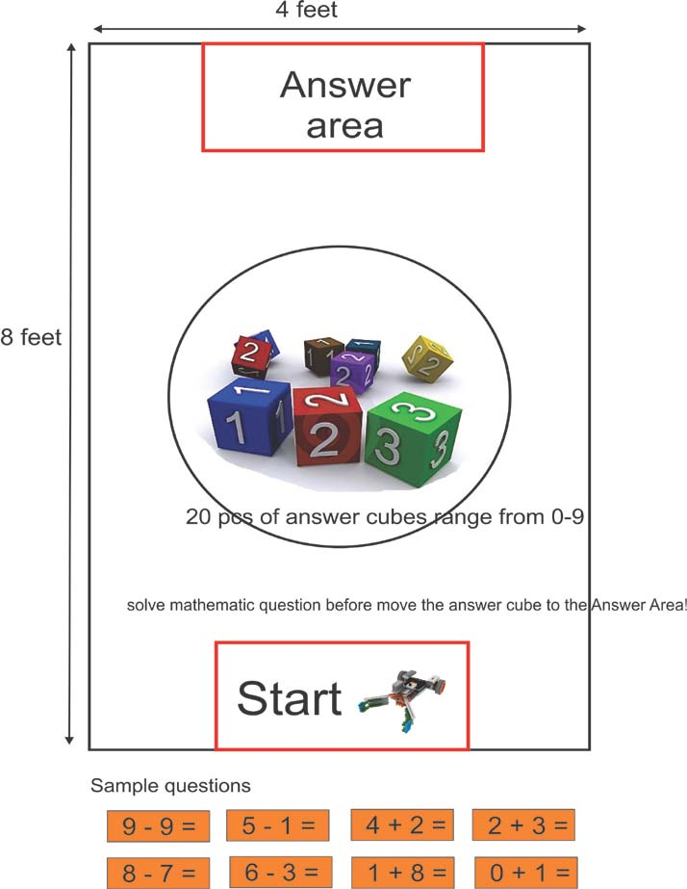

2. | Goma Brain Mission

Summary :

Level | Kindergarten-Primary：4-9 years old
Team | Individual game
Robot | GOMA Hand + Brain
Mission | Programming with cards to complete the first stage mission, and use remote controller to complete the second and third stages missions.
Robot Building | In advance
Game Method | Mission completion + time recorder

Rules and Regulations:
A. Participants need prepare their robots in advance and not allowed to touch the robots during competition.
B. Robots are limited to 30 cm *30 cm *30 cm during the whole competition.
C. All robots need assembled with MRT1 (GOMA) series.
D. All robots need play with remote controller.
E. Participants must prepare their own robots for competition, not allowed to share the robot with others.
F. Participants need check their robots before competition. Not allowed to touch or fix the fallen parts from robots during competition without the permission of referees.
J. Time limit for game is 3 minutes.
H. After receiving the calling from referees, participants need put the robots on START before competition and waiting for competition.
I. All participants need play the games as the referees order, and every participant has one chance to complete the whole mission, the records will be noted.
J. The followings are considered to be the end of the game :

1). The robots arrive at the END of competition.
2). Robots stop for 10 seconds during competition.
3). Participants touch their robot during competition without the referee’s permission.
K. Participants need sign and confirm the competition result at the end of the game.
◆ 3 missions in the whole competition (60 marks in total )
* We provide 4 options for reference, and will select one of 4 options as our competition on spot.
* Mission 1 (Time Programming) – Programming with cards to make the robot go through the first stage,at the end of first stage the robot need move to the door and make the LED on flash.

- Finish the path, get 10 scores. (If not finish, no scores)
- Make the LED on door flash, get 10 scores.

* Mission 2 ( Calculation question) – Calculate and move two cubes to the appointed circles.

- If move the cubes to the appointed circles, get 20 scores (10 scores/cube).
If the calculate is right, then get 30 scores.

* Mission 3 (Delivery) – Move the cubes to pointed place (10 scores in total)

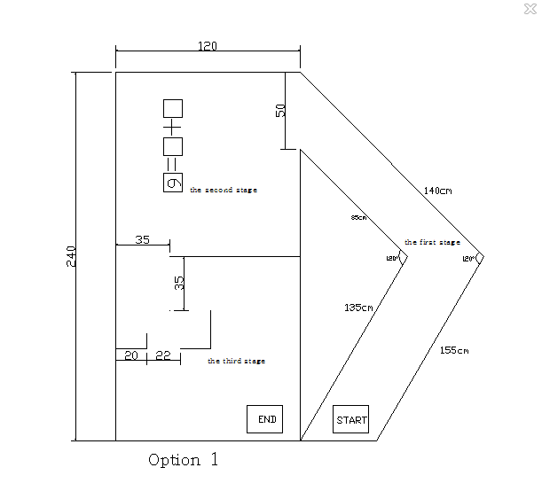

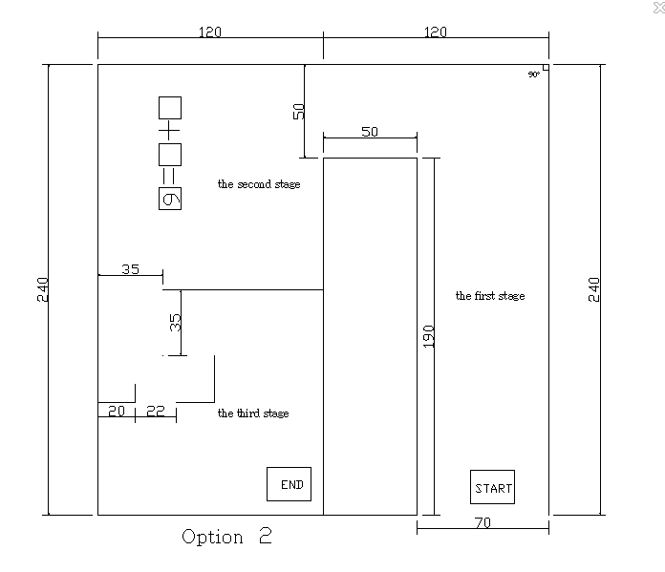
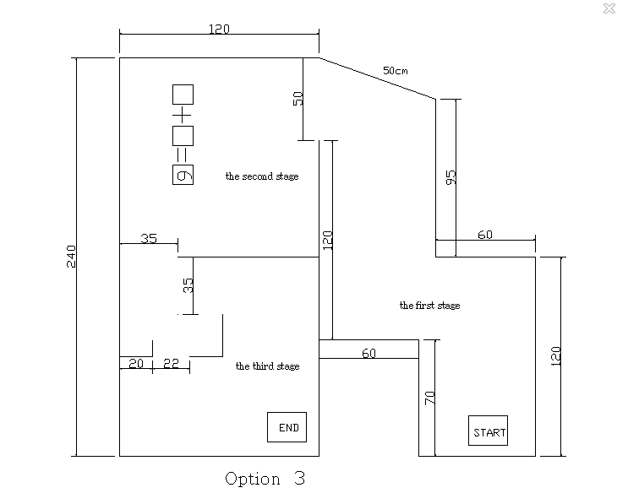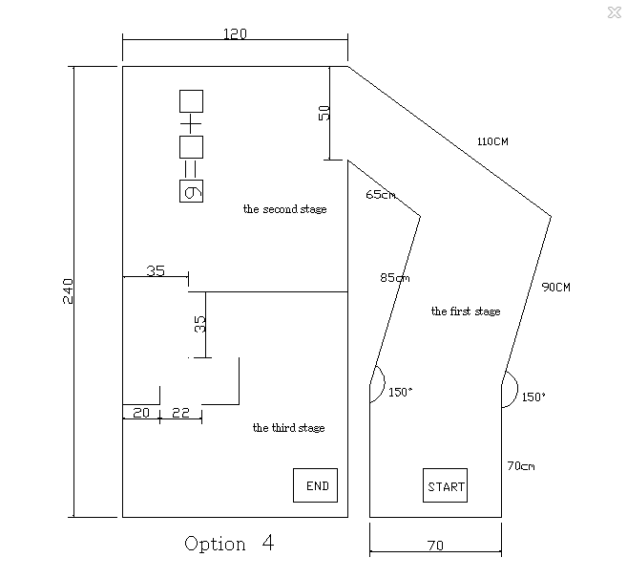

3. | STEAM Mission Game

Summary

Level | Primary School (7-12 years old)
Team | Individual
Robot | STEAM-focused Educational Robot Kit
Mission | 5 Missions
Robot Building | In advance
Game Method | Mission completion and record

Rules and Regulations :

A. Use after school robot teaching aids that operate in infrared rays/IR method. Robot building and programming should be completed prior to the game (modification at the game site is unavailable).

B. Maximum size of robots are limited to 25.0cm×25.0cm×25.0cm. (※ Robot size will be examined before starting the competition)

C. There are no limitations on robot motions, but it is prohibited to use equipment not included in the teaching aids officially recognized by the game.

D. Robot should be motioned by a remote control. It should be equipped with more than 2 wireless communication channels in infrared ray (IR) method.

E. Participants can install a device on robot arms and legs to move or push the object. The device should be manufactured using officially recognized robot teaching aids. Using recycling or other materials is prohibited.

F. The number of DC motor/servo-motor to be used is not limited, but modifying the motor will result in disqualification.

G. If it is necessary to have a laptop, individual participants should prepare it.

H. It is completely prohibited to jointly use the manufactured robot with other teams.

I. Participants bear the responsibility on damage and loss of robot incurred by their carelessness.

J. The maximum game time is 4 minutes.

K. At the call of the referee, 1 robot built by the called team should be located at the designated starting point in the game room.

L. In accordance with the referee’s directions and turn, pre-guidance, participation and robot checking procedures should be made to proceed to mission taking (Only 1 mission taking opportunity will be given and its point will be recorded as the final record).

M. The followings are considered to be the end of the game.
1) Robot safely arrives at the destination after accomplishing the mission (point calculation/recording)
2) Robot stops during the competition for more than 10 seconds.
3) Participants touch the robot physically.
4) During robot traveling, other game parts (mission objects, obstacle-Ping-Pong balls, Yogurt bottles, robot parts) pass the measuring instrument by the robot (point calculation, record 0 point).

N. There are 5 types of missions (knocking down by solving questions, dropping,pushing in, pushing to get scores, etc.). There are also cases that participants should solve robot quizzes or the four fundamental arithmetic operations to fulfill the missions (for details, refer to 7. Game Rules and Details)

O. After fulfilling the missions, participants confirm the referee’s record and mission accomplishment by putting his/her signature.

P. More details about STEAM mission, please refer to the attached file of STEAM mission introduction.

Mission:
◆ Mission1 Knocking Down Zenga

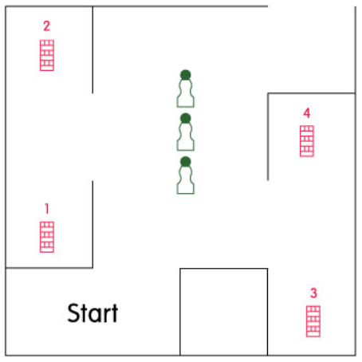

◆ Mission2 Ping-Pong Ball Dropping on Yogurt Bottles
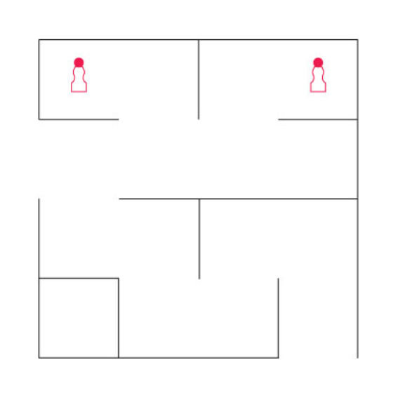
◆ Mission3 Moving woodchips to complete a formula

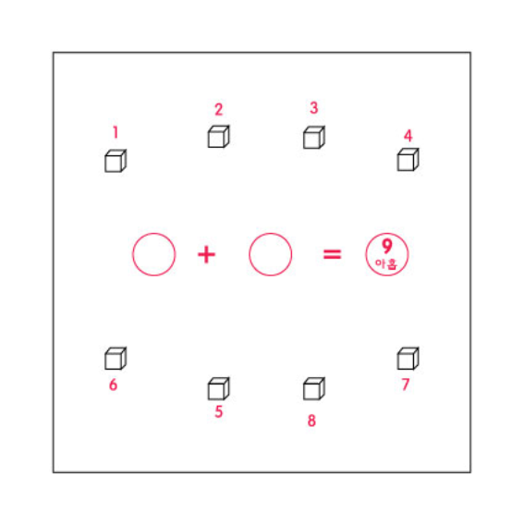

◆ Mission4 Pushing balls to get scores
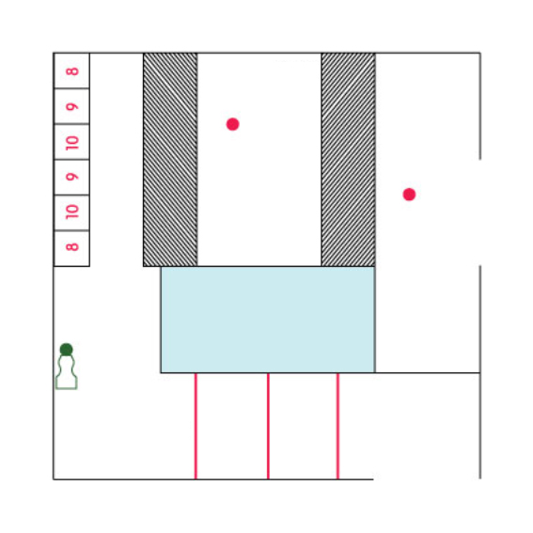
Declaration Strip
Slope
Unpaved Road

◆ Mission5 Passing the woodchip between walls

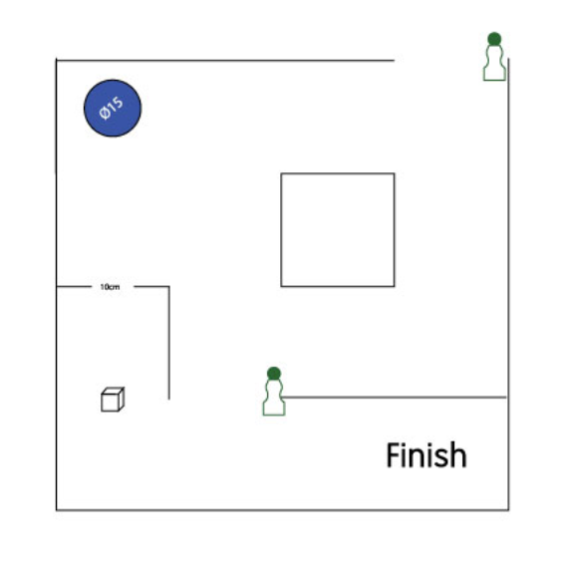

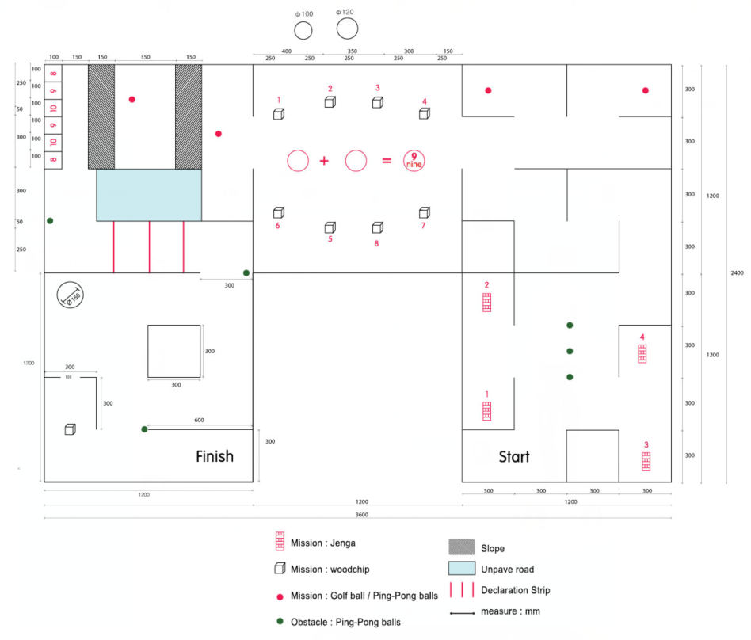

4. | R-Sports Mission (group - Volleyball)

Summary

Level | Primary School (7-12 years old)
Team | 2 participates per team with robots
Robot | Educational Robot Kit
Mission | Similar to volleyball to move the most number of balls into opponents’ field
Robot Building | In advance
Game Method | Mission completion and record

Rules and Regulations :

- All teams will compete based on a ‘knock-out’ system with only the winning teams will proceed to the next round of competition.

B. Each team shall be consisted of 2 students with each student is controlling one robot to play in the volleyball match.

C. Prizes and trophies will be awarded to the Top 4 teams.

D. Each team will have 20 ping-pong balls in the own field at the starting of the competition.

E. The teams who successfully move the most number of balls into opponents’ field in the match will be the WINNER.

F. If one of the team can transfer all their ball into opponents’ field during the match, the opponents is considered “SUDDEN DEATH” and lost in the match.

H. Each team has to grab the ball and transfer the ball into the opponents’ field.

I. Time limit for each game shall be 3 minutes.

J. No extra time shall be played in the event of a draw.

K. In the event of a DRAW on FULL-TIME, PK Round will be played by selecting one robot from each team to transfer the ball into opponent’s field in 30 seconds.

L. The robot must not have any foreign part (includes rubber band, black tapes and scotch tapes). If any participant violates the rules and regulations, the he / she would be IMMEDIATELY disqualified.
M. Maximum dimensions may not be exceeded. Robots are limited to 25cm (Length) by 25cm (Width) by 25cm (Height) during the whole competition.

N. After calling in the participants, referee will check all robots and start the competition after all robots is ready.
O. Participants are not allowed to touch the robots after the competition is started.

P. The parts which are fallen or broken from the robots cannot be fixed back onto the robots during the match.

Q. Upon removal or a robot from the playing pitch, it can only re-enter the match upon referee’s approval.
R. In case of technical problem such as robots are uncontrollable, the referee will pause the match and help participants to turn off and on the robot only. If the robots still cannot function, then the participants will be disqualified.
S. If the ping-pong is thrown outside the field, the ball will be put back into the field immediately by the referee based on the real volleyball match rule.

Game Field: 1620 X 2500 mm (Height of Divider is 8 cm)

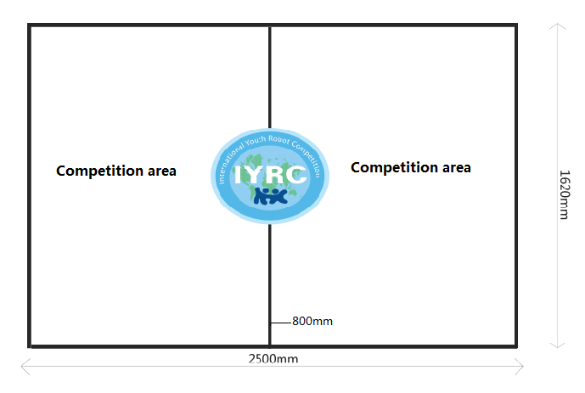

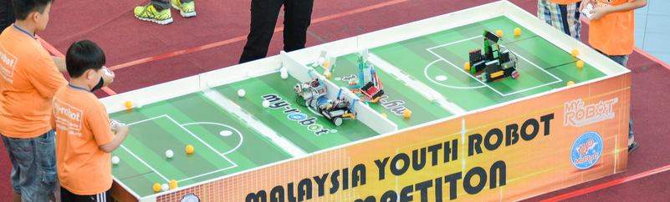
5. | 3vs3 Soccer Robot

Summary

Level | Primary School (7-12 years old)
Team | 3 participants per team and 3 robots per team
Robot | Educational Robot Kit
Mission | Soccer match using Remote Control
Robot Building | In advance
Game Method | Team tournament

Rules & Regulations:

A. All the games will be based on “knock out” system. All the teams will be distributed in opposing pairs
by committee randomly.

B. Each team shall consist of 3 robots and 3 students with each student controlling one robot. Teams can
choose between two roles variants: 1 defender + 2 strikers or 2 defenders + 1 striker.

Defenders:
- cannot leave his area (his half of the field), therefore cannot enter opponents area.
- allowed to enter own penalty area to protect the gate, but stay there not more than 10 seconds

Strikers:
- allowed to enter both own and opponent’s area
- does not allowed to enter own penalty area
- allowed to enter opponent’s penalty area to hit the gates, but not for more than 5 seconds.

The team should distribute the roles prior the game and provide this information to referee. Roles cannot be changed during the match, but can be changed between the matches.

C. Prizes and trophies will be awarded to the Top 3 teams.

D. Time limit for each game shall be 5 minutes.

E. Extra time shall be played only in the event of a draw.

F. The ‘knock-out’ stage shall not consist of any points and the winner of the game shall proceed to the next round. Extra time shall be played in an event of a DRAW. The time limit for extra time shall be 1 minute.

G. In the event of a DRAW by the end of extra time, a penalty shoot-out shall decide the match with each team being allocated 3 penalties. ‘Sudden death’ penalties shall decide the match in the event both teams are still tied for score. The team that misses the first penalty with the other team scoring their penalty, losses the game.

H. The robot must not have any foreign part (includes rubber band, black tapes and scotch tapes). If found guilty, the player would be IMMEDIATELY disqualified.

I. Maximum dimensions may not be exceeded. Robots are limited to 25cm (Width) * 25cm (Length) * 25cm (Height).

J. There is no goal keeper and the defending robot can only stay within the penalty area for a maximum of 10 seconds.

K. A robot may not handle the ball for more than 5 seconds.

L. Players are not allowed to touch the robots unless permission is given by the referee.

M. Upon removal or a robot from the playing pitch, it can only re-enter the game upon referee’s approval.

N. An offender will be issued a yellow card. Upon receiving 2 yellow card, the player will be removed.

O. The team that concedes the goal will restart the game from position pointed by referee.

P. For penalties ball will be placed on a certain point of the circle. Robot which making a shot should start its movement from the point, hit the ball and can not push the ball into the gate.

Q. In a time breaker Penalty after game take from one side only.

R. After penalty during normal play, penalty score or miss, restart the game 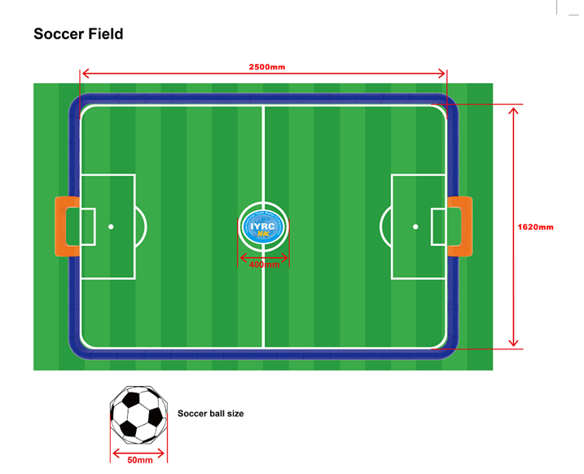

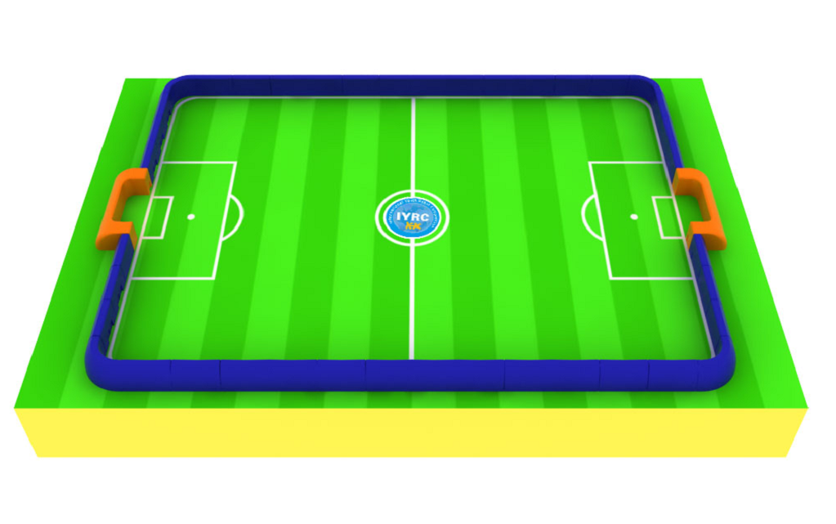

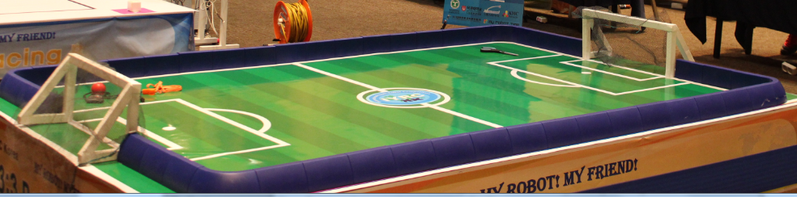

6. | Coding Mission

Summary

Level | Primary School (7-12 years old) // Middle School(13~16 years old)
Team | 1 participants for 1 team (1 robot per team)
Robot | Educational Robot Kit
Mission | To follow the line with programming with missions  Beginner Course for Primary School 7~12 years participants  Advanced Course for Primary School 13~ 16 years participants.
Robot Building | In advance (on spot programming)
Game Method | Time record + Mission completion

Rules and Regulations :

A. Participants shall make a program(1~2 hours) on spot to follow the line and complete some missions.

B. The participants who accomplished the mission with the shortest time will be the winner.

C. Players are not allowed to touch the robots unless permission is given by the referee.

D. Maximum size of robots are limited to 25.0cm×25.0cm×25.0cm. (※ Robot size will be examined before starting the competition).

E. Robot can have structure to push or grab the object.

F. Spare robot can be allowed after checked by referee.

G. No Remote controller, only the robot will be moved by itself with IR 5 sensors.

H. Not allowed special battery and motors, main board, foreign material, allowed 9V battery pack (In approved kit).

I. During programming (1 or 2 hours), participants has 2 times to test on the real play ground.

J. Game will be ended in case of the following:
- After mission clearing, a robot is arrived at the end point safely (time record)
– A robot is stopped for more than 10 seconds
- A participant touches the robot without referees approval.
- A robot is moved outside of the playground.

Beginner Course :

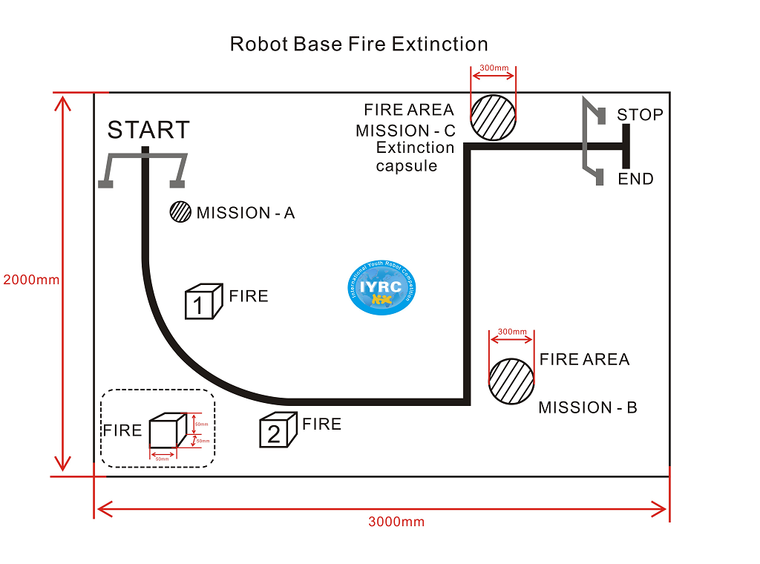
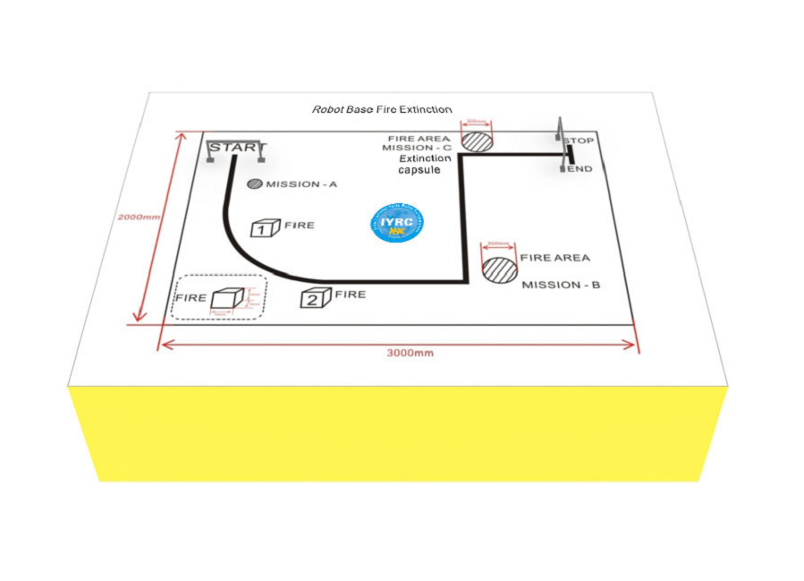

Advanced Course :

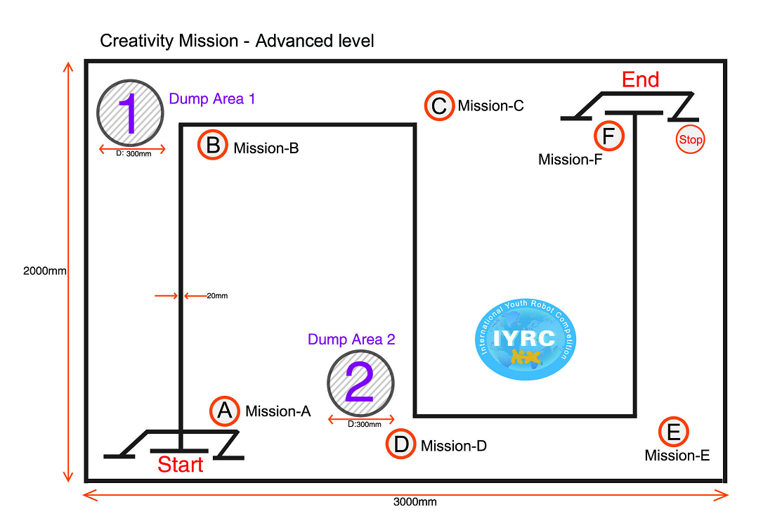
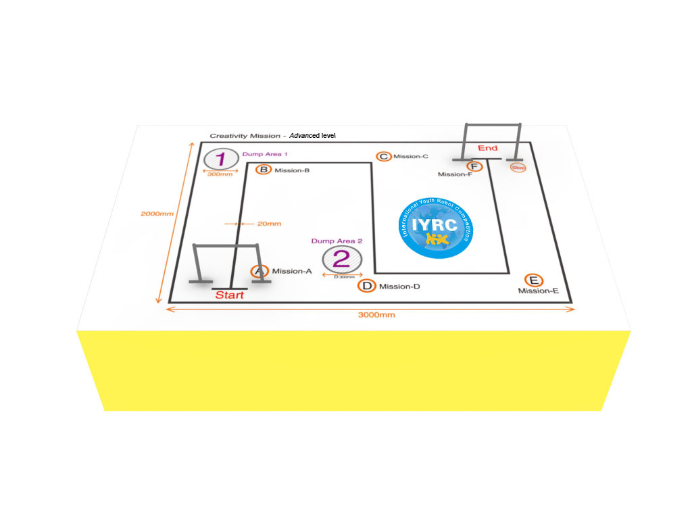

Record Sheet

Beginning Level:

Time (seconds) | Time Rank | Time Point | Start Mission | Fire 1 | Fire 2 | Mission A | Mission B | End Mission | Total | Rank
25 | 1 | 100 | 10 | 10 | 10 | 10 | 10 | 10 | 160 | 1
30 | 4 | 85 | 10 |  | 10 |  | 10 | 10 | 115 | 4
27 | 2 | 95 | 10 | 10 | 10 |  |  | 10 | 135 | 3
28 | 3 | 90 | 10 | 10 | 10 | 10 | 10 | 10 | 150 | 2
35 | 5 | 80 | 10 | 10 |  |  |  | 10 | 110 | 5

Advanced Level:

Time (seconds) | Time Rank | Time Point | Bottle Mission | Mission B | Mission D | End  Mission | Total | Rank
25 | 1 | 100 | 30 | 10 | 10 | 10 | 170 | 1
30 | 4 | 85 | 20 |  | 10 | 10 | 125 | 4
27 | 2 | 95 | 25 | 10 | 10 |  | 140 | 2
28 | 3 | 90 | 20 | 10 | 10 | 10 | 140 | 2
35 | 5 | 80 | 15 | 10 | 10 |  | 115 | 5

7. | Creative Robot

Summary

Level | Primary / middle School (7-12 / 13-16 years old) / Teachers
Team | 1~5 students for 1 team (1 robot per 1 team) / 1~5 teacher for 1 team
Robot | Educational Robot Kit
Mission | Create a robot
Theme  Robot Building | No theme  In advance
Game Method | Presentation and demonstration

Rules and Regulations:

A. Participants shall build a robot in advance.

B. Participants should submit the robot manual and the related material such as photos and videos to the organizer.

C. Based on the manual, participants has to introduce their robots to the referee on the stage.

D. Score shall consist of Creativity, Uniqueness, Function, and Presentation skill.

E. We provide bonus awards for teachers.

