STEAM Mission Game

1. Overview: participants use STEAM-focused educational robot teaching aids to make a robot forfulfilling missions and get tested on their theory and knowledge about robot science (S) and technology (T). Participants’ STEAM capability on theory and practical technique is evaluated comprehensively by adding time points and mission accomplishment points.

2. Objectives: to establish foundations of robot science by promoting basic science and basic knowledge learning on robot; to create a convergent educational venue by fostering unlimited imagination and creativity of individual students through mission accomplishment and robot building and control activities for achieving faster time records.

- Characteristics: STEAM-focused robot game, rather than a method simply relying on
manufacturing or control of equipment unit. Question solving (science), robot building (science, engineering), operation (technique), mission accomplishing (math, technology), and design to shorten record time (art)

4. Participants: Elementary 1~6 Graders (1 robot per person)

5. Robot Regulations
1) Use afterschool robot teaching aids that operate in infrared rays/IR method. Robot building
and programming should be completed prior to the game (modification at the game site is
unavailable).

- Size of robot: the minimum size of the robot that makes movement for motion should be
more than 10.0cm×10.0cm×5.0cm and its maximum size should be less than 25cm×25cm×25cm. (※ Robot size will be examined before starting the competition)

- There are no limitations on robot motions, but it is prohibited to use equipment not included
in the teaching aids officially recognized by the game.

- Robot should be controlled by infrared ray remote control.
5) Participants can equip a device with robot arms and legs to move or push the object. The device should be manufactured using officially recognized robot teaching aids only. Using other materials is prohibited.
- The number of DC motor/servo-motor to be used is not limited, but modifying the motor will result in disqualification.

7) If it is necessary to have a laptop, individual participants should prepare it.
- Each team should use its own robot. Changing robots between teams or using robot of other team is prohibited.

9) Participants bear the responsibility on damage and loss of robot incurred by their carelessness.

6. Game Regulations
1) Participating teams should bring the robot (pre-built) with more than 2 wireless
communication channels in IR method to the game room and fulfill the missions (Bluetooth
and Zigbee communication is prohibited).

- The maximum game time is 5 minutes.

- At the call of the referee, 1 robot built by the called team should be located at the designate
starting point in the game room.

- In accordance with the referee’s directions and turn, pre-guidance, participation and robot check
procedures should be made to proceed to mission taking (Only 1 mission taking opportunity will be given and its point will be recorded as the final record).

- The followings are considered to be the end of the game:

a. Robot safely arrives at the destination after accomplishing the mission (point calculation/
recording)

b. Robot stops during the competition for more than 10 seconds.

c. Participants touch the robot physically without referee’s approval.

d. During robot traveling, other game parts (mission objects, obstacle-Ping-Pong balls,Yogurt
bottles, robot parts) pass the measuring instrument by the robot (point calculation,record 0 point).

- There are 5 types of missions (knocking down by solving questions, dropping, pushing in, pushing to get scores, etc.). There are also cases that participants should solve robot quizzes or the four fundamental arithmetic operations to fulfill the missions (for details, refer to 7. Game Rules and Details)

- After fulfilling the missions, participants confirm the referee’s record and mission
accomplishment by putting his/her signature.

7. Game Rules and Details

Robot should fulfill 5 missions while passing or avoiding obstacles(unpaved roads,embossing sections,Ping-Pong ball on a yogurt bottles) on the major path to reach the destination as soon as possible.All of 5 mission fields connected in one path.

- Participants can only control the robot at the designated control seat (controlling the robot away from the designated seat will results in disqualification).

2) Time will be recorded from the moment that participants get into the designated control seat
and the robot passes the measuring instrument to the moment that the robot reaches the
destination (100 points total)

- Mission scores are calculated by adding individual points of the completed missions after finis
5 missions (100 points total).

4) Robot should pass 2 obstacle sections located at the game path.
- Unpaved roads (non-woven fabric-thumbtacks in places), embossing (diameter: 4mm, 3 steel axis)

- Robot should travel while avoiding obstacles (Ping-Pong balls on yogurt bottles) at the game path.

The total number of obstacles is 6. If the Ping-Pong ball on the yogurt bottle drops, -5 point per ball dropping (it doesn’t count as a minus point when the robot touches the yogurt bottle but the Ping-Pong ball does not drop).

- Participants selects a Ping-Pong ball (30 for elementary 1~3 grade and 50 for elementary 4~6 grade) from the lottery wheel while previous participants are attending the game and solve the questions indicated on the selected Ping-Pong ball.

- Participants are responsible for interruption of travel by mission objects (Ping-Pong balls/wood chips) dropped or pushed during the robot travel.

8) If the mission object passes the measuring instrument during the robot travel and measurement
is completed, the mission point at that time is recorded (time point is recorded 0 point as it
is considered that the robot does not complete the game).

◆ 5 Score Missions (100 points)

* Mission1 (Knocking Down Zenga) – Knock down Zenga that matches the answer of the question selected before measurement - 10 points total

* Mission2 (Ping-Pong Ball Dropping on Yogurt Bottles) – Drop off a Ping-Pong ball on a yogurt bottle (2 balls) - 10 points and 20 points respectively

* Mission3 (Moving woodchips to complete a formula) – Move 2 woodchips (3cm cube) with
numbers from 1 to 9 to complete the formula.
- Move the woodchip into the circle 10 point (20 points for 2 woodchips), additional 10point when the answer is correct, 30 points total

* Mission4 (Pushing balls to get scores) – Push 2 golf balls to get the score corresponding to location of the golf balls - 10 points maximum respectively (8,9,10 points), 20 points total maximum.

* Mission5 (Passing the woodchip between walls) –Pass the woodchip (3cm cube) through the walls (10cm distance) to get to designated circle.
–20 points total

8. Evaluation

- Time point of the robot that completes all missions and reaches the destination safely within the shortest period of time will become the time base point. From the time base point, 0.5 point step is subtracted for the following ranks, respectively ( step point modification is possible depending on the number of participating teams). The final rank is determined by adding the mission points to the time points.
2) Points are calculated by adding the time point (100 points maximum) and the mission point (100 points maximum). (Refer to the below evaluation chart and rank chart)

Time (min) | Time Rank | Time Point | Mission1 | Mission2 | Mission3 | Mission4 | Mission5 | Total | Rank
1.19 | 1 | 100 | 0 | 20 | 30 | 20 | 20 | 190 | 7
1.32 | 3 | 99 | 10 | 20 | 20 | 17 | 20 | 196 | 3
2.01 | 6 | 97.5 | 10 | 20 | 30 | 18 | 20 | 195.5 | 4
1.54 | 5 | 98 | 10 | 20 | 30 | 20 | 20 | 198 | 1
1.22 | 2 | 99.5 | 10 | 20 | 25 | 19 | 20 | 193.5 | 6
2.25 | 8 | 96.5 | 10 | 20 | 30 | 18 | 20 | 194.5 | 5
2.31 | 9 | 96 | 0 | 20 | 20 | 10 | 15 | 161 | 9
1.48 | 4 | 98.5 | 10 | 20 | 30 | 20 | 0 | 178.5 | 8
실격 |  | 0 | 10 | 20 | 30 | 20 | 20 | 100 | 10
2.16 | 7 | 97 | 10 | 20 | 30 | 20 | 20 | 197 | 2

※ STEAM Mission Details
◆ Mission1 –Knock down Zenga corresponding to the answer of the question selected from the lottery wheel (Zenga corresponding to each answer is located at the same distance from the start point)
· The answer of the question is 1 among 4 (1,2,3,4)
· There will be 30 questions for elementary 1~3 grade and 50 questions for elementary 4~6 grade in lottery wheel.
All questions and answers are disclosed in advance. Question numbers are re-arranged, different from the disclosed order. Questions is set in non-disclosure
* Game Missions
· Awaiting participants select one Ping-Pong ball from the lottery wheel and solve the question corresponding to the number they select.
· When the game begins at the control seat, participants control robot to knock down Zenga (tower of wooden blocks) corresponding to the correct answer (one in 1, 2, 3, 4) in Mission 1 section.
· 10 points when the correct Zenga is knocked down. Otherwise, 0 point.
· Minus 5 points when the Ping-Pong ball on the yogurt bottle drops

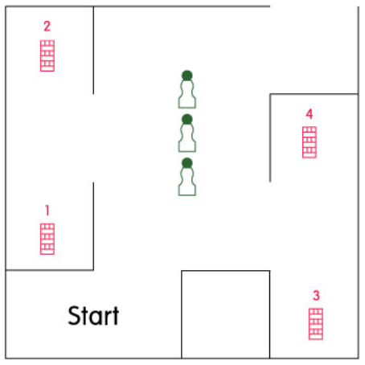

◆ Mission2 –Drop 2 Ping-Pong balls on yogurt bottles while traveling on the path
· 10 points for each dropped Ping-Pong ball on the yogurt bottle. (maximum 20 points if both balls are dropped)
· Points are counted when the Ping-Pong ball drops even if the yogurt bottle is not knocked d own.

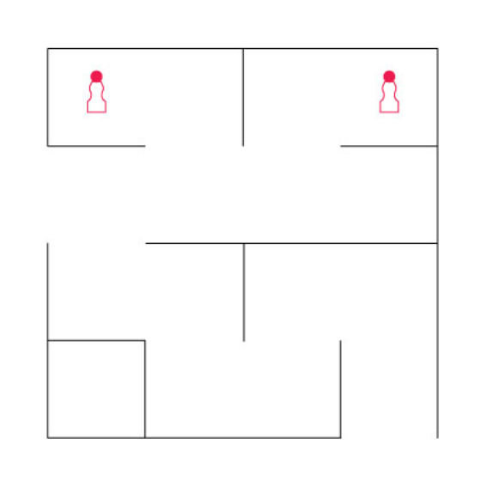

◆ Mission3 – 10 points when the woodchip (3cm cube) is moved to the designated circle (12cm diameter), without touching the line. 20 points gained for 2 woodchips. Additional 10 points when the formula is completed correctly. 30 points total maximum:
· 10 points for each woodchip moved into the circle even if the formula is incorrect (but only 5 points for woodchip that touches the line of the circle, even slightly)
·
· 10 points when the formula formed by moving the number is correctly completed
· It is fine to touch or move other woodchips during traveling, touch lines by robot, adjust woodchip position at any time.

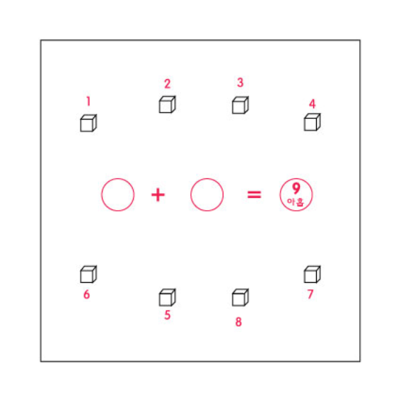

◆ Mission4 –Push one golf ball on the head of the slope and another golf ball on the foot of the slope. Gain the point corresponding to the point section that the ball arrives.
· 20 points total maximum when both balls arrive at 10 point section
· Point arrangement is 8, 10, 9, 10, 9, 8 from the left.
· It is fine to push both balls into the same one point section
· It is fine that the ball rolls down to the foot of the slope in the course of pushing.

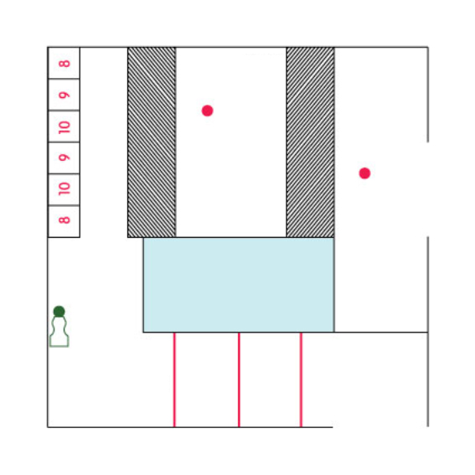
deceleration strip

unpaved road
slope

◆ Mission5 –Move the woodchip (3cm cube) into the designated circle (15cm diameter) by passing through the wall (10cm distance)
· 20 points when the woodchip is entered into the circle by passing through the wall (but only 10 point if the woodchip touches the line of the circle)
· 0 point when the woodchip does not get into the circle
· 0 point when the woodchip does not pass through the wall

